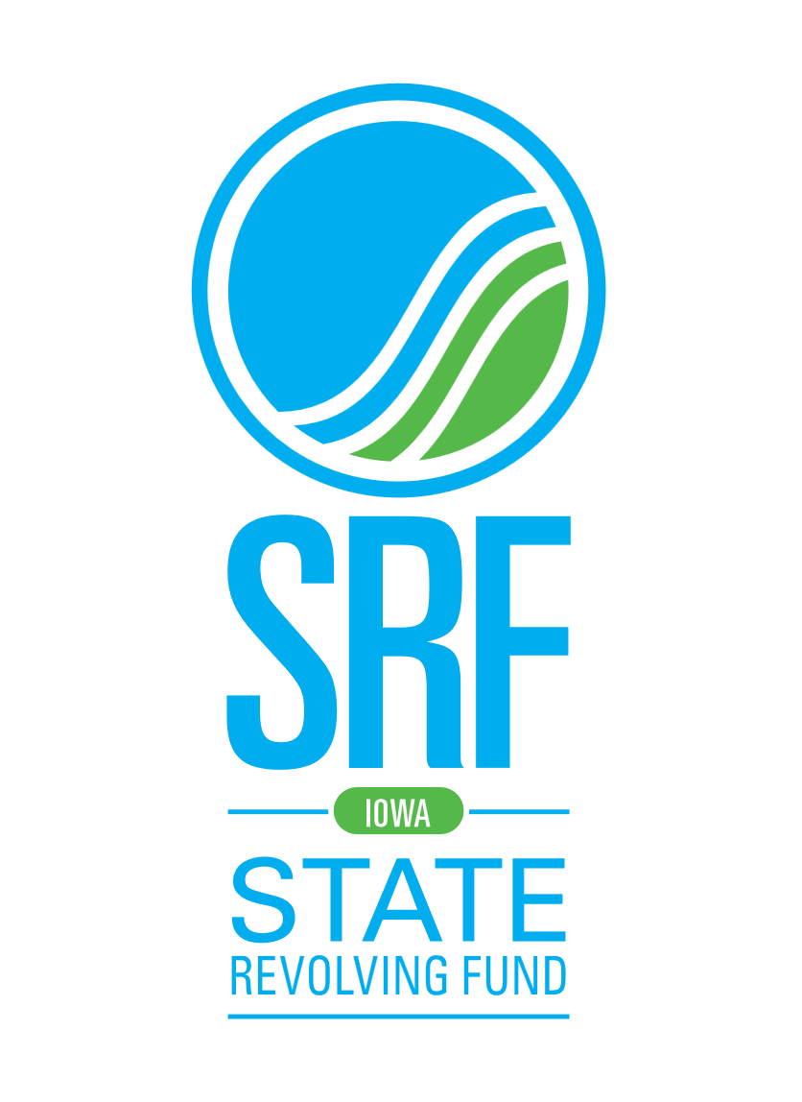
Lender Participation Agreement
Water Quality Linked Deposit Programs

Lending Institution:
Mailing Address:

Phone:

The above-named lending institution (“Lender”) hereby agrees to participate in the Local Water Protection Program (LWPP), Livestock Water Quality Program (LWQ), Storm water Quality Program and/or the Onsite Wastewater System Assistance Program (OSWAP). All are linked deposit programs designed to improve water quality. The Lender agrees to the following program requirements and Lender responsibilities.
- Borrowers applying for a linked deposit loan must have a plan and cost estimate approved by the appropriate conservation or environmental entity. Costs directly related to the implementation of the project are eligible. Costs for the purchase of land are not eligible costs.
- All new loan applications will comply with program loan and term limits:
  - LWPP – loans of $5,000 to $500,000 with terms to 10 years.
  - LWQ – loans of $10,000 to $500,000 with terms up to 15 years.
  - Storm water – loans of $5,000 and up with terms to 20 years.
  - OSWAP – loans of $2,000 and up with terms to 10 years.
  - Total outstanding balance for a borrower cannot exceed $500,000.
- The Lender will charge the borrower up to, but no more than, 3% interest above the underlying rate.
- A deposit account will be created for the Iowa Finance Authority (IFA) into which the funds will be deposited. In most cases, there will be one account per lending institution. The account will earn no interest and be charged no fees. The funds will remain in the account for the duration of the loan. Annually, an amount equal to the principal paid on the loan, or scheduled to be paid on the loan, will be withdrawn from the account by IFA so that the amount of the deposit equals the outstanding principal balance of the loan.
- IFA is a governmental entity and, as such, is exempt from the definition of “customer” as described in the 31 CFR 103.22(d)(2)(ii) through (iv). The Customer Identification Program (CIP) requirements do not apply to accounts opened by IFA.
- The linked deposit is not security for the loan nor is it a loan guarantee. The Lender bears all financial risk for the loan.
- Loan agreements will be written so that all loans are fully amortized.
- The loan is to be paid in full and the deposit will be withdrawn if the property where the practice was constructed or installed is sold or transferred.
- The Lender will notify IFA in a timely manner of ownership changes, personnel changes and any other information that is relevant to the program. Updated Lender Participation Agreements will be required when there is a legal name change of the Lender.
- IFA can limit the amount of deposits in any lending institution if there are concerns about the financial condition of the institution.
- This agreement can be terminated at any time, given 90-day prior written notice and replaces previous Lender Participation Agreements.

The undersigned is duly authorized by the Lender to agree to all terms and conditions described in this Lender Participation Agreement.

Authorized Signature Date

Typed Name and Title

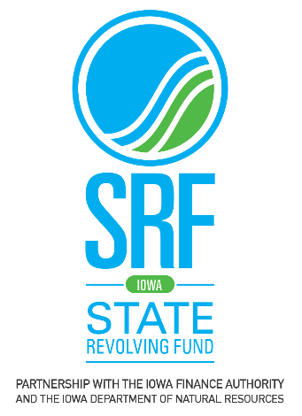
Lender Instruction Form
For
Water Quality Linked Deposit Programs

- Sign up as a participating lender. To become a participating lender, sign and return the Lender Participation Agreement to IFA.

- Lender either approves or denies loan application based upon the lender’s application process and loan underwriting guidelines. The linked deposit is not security for the loan nor is it a loan guarantee. The deposit is only to provide funds at 0% and the interest rate charged to the borrower cannot exceed 3%.

- When the loan is approved, lender enters the borrower’s information on www.iowalinkeddeposit.com.

- After the project has been completed, inspected and approved by the appropriate environmental or conservation agency, the lender will be notified by email that funds can be requested. Lender logs in to IFA’s website to request funds.

- The lending institution creates a deposit account for IFA into which the funds for all linked deposits will be deposited. The account earns no interest and is charged no fees.

- IFA deposits funds in the lending institution and the borrower receives his/her loan from the lending institution.

- IFA receives monthly bank statements for the deposit account.

- Once a year, the lending institution communicates to IFA the amount of principal that has been repaid on the loan. IFA withdraws that amount from its account so that the amount of the deposit equals the principal amount of the loan.

For more information, contact:
Jane Larson
Jane.Larson@IowaFinance.com
515-452-0465
Iowa Finance Authority
1963 Bell Ave, Suite 200 - Des Moines, IA 50315
800-432-7230
www.iowalinkeddeposit.com

